# Anjom Nour Anika

# ID: IT-18013

# Ping: The ping tool is used to test whether a particular host is reachable across an IP network . A ping measures the time it takes for packets to be sent from the local host to a destination computer and back. The ping tool measures and records the round trip time of the packet and any losses along the way.

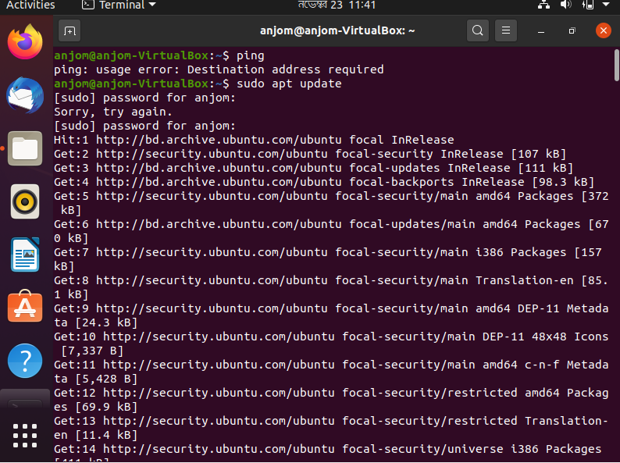

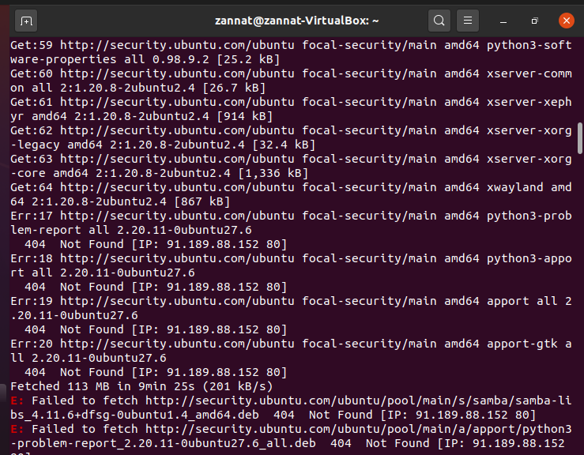 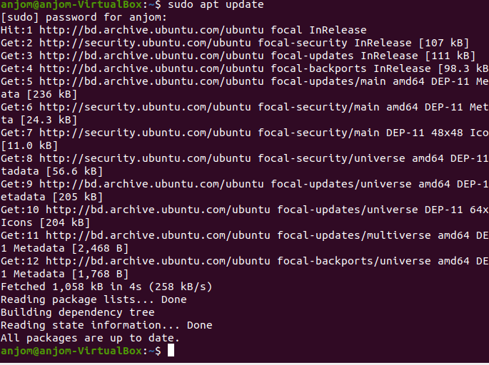

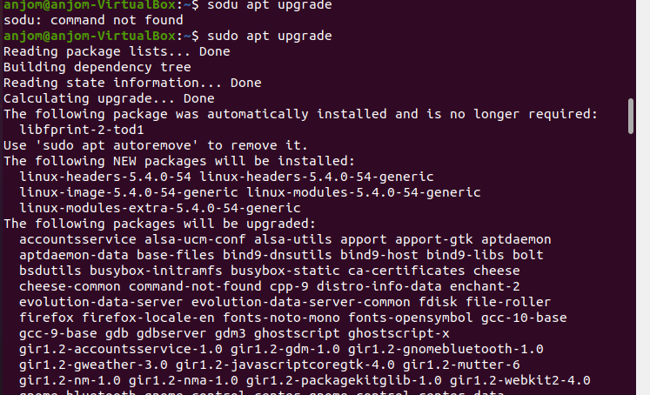

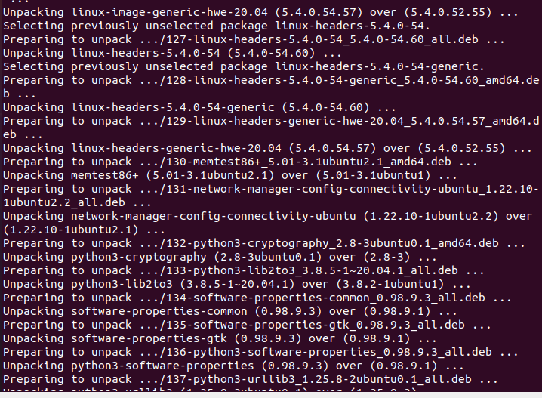

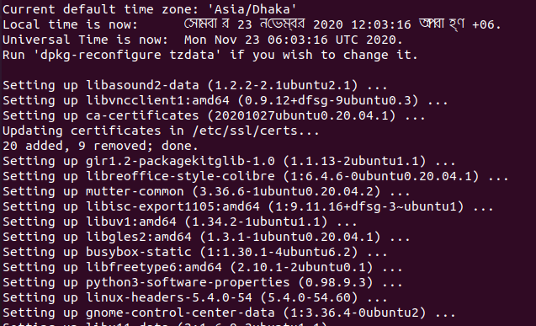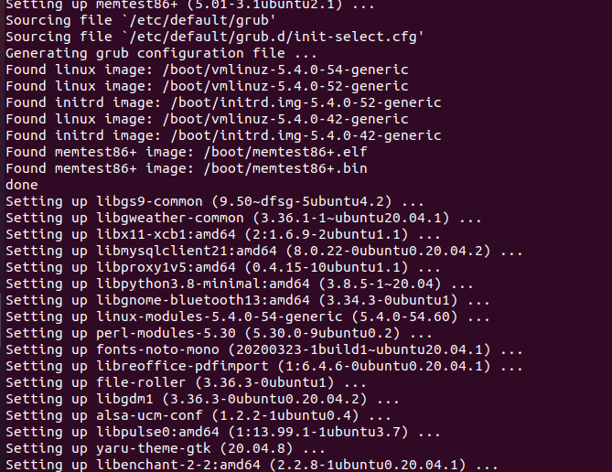 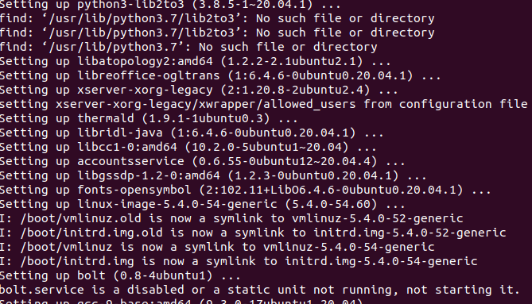

# Curl: Curl is a command line tool that allows to transfer data across the network . It supports lot of protocols out of the box , including HTTP, HTTPS, FTP, FTPS, SFTP,IMAP,SMTP,POP3 and many more . When it comes to debugging network requests ,curl is one of the best tools you can find.

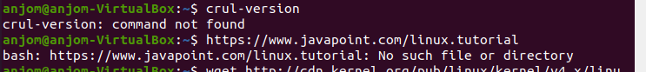

# Wget : Wget is a free GNU command line utility tool used to download files from the internet. It retrieves files using HTTP,HTTPS, and FTP protocols. It serves as a tool to sustain unstable and and slow network connections.

# Tc: tc is the user space utility program used to configure the Linux Kernel Packet Scheduler. Tc is usually packaged as part of the iproute2 package.

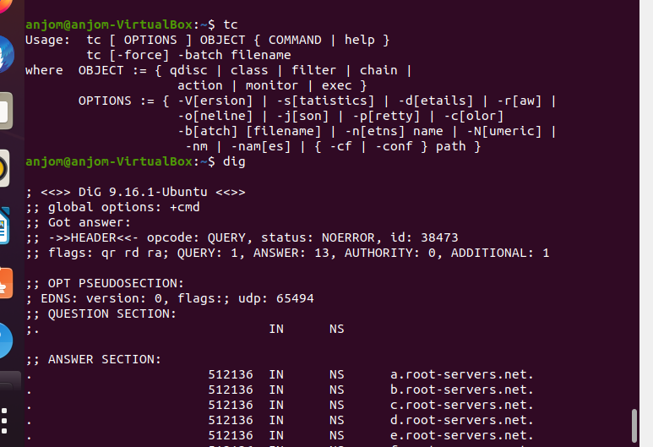

# Dig: dig is a network administration command line tool for querying the Domain Name System . dig is useful for network troubleshooting and for educational purposes . It can operate based on command line option and flag arguments , or in batch mode by reading requests from an operating system file.



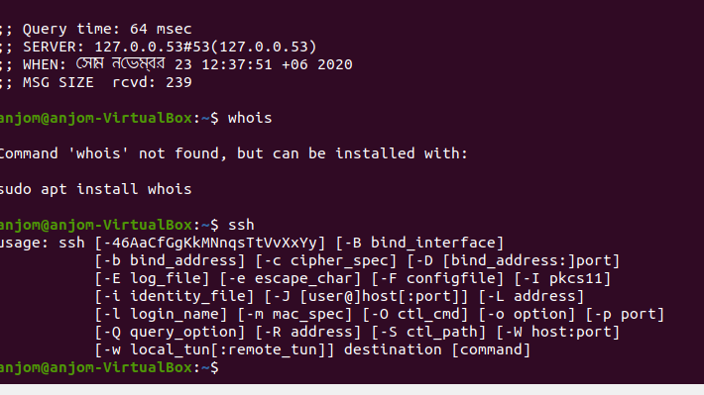

# Whois: WHOIS is a query and response protocol that is widely used for querying databases that stored the registered users or assignees of an internet resource , such as a domain name, an IP address block or an autonomous system , but is also used for a wide range of other information.



# SSH: SSH or Secure Shell is a cryptographic network protocol for operating network services securely over an unsecured network. Typical applications include remote command-line , login, and remote command execution, but any network service can be secured with SSH.



# SCP: Secure Copy Protocol is a means of securely transferring computer files between a local host and a remote host or between two remote hosts. It’s based on the Secure Shell Protocol.

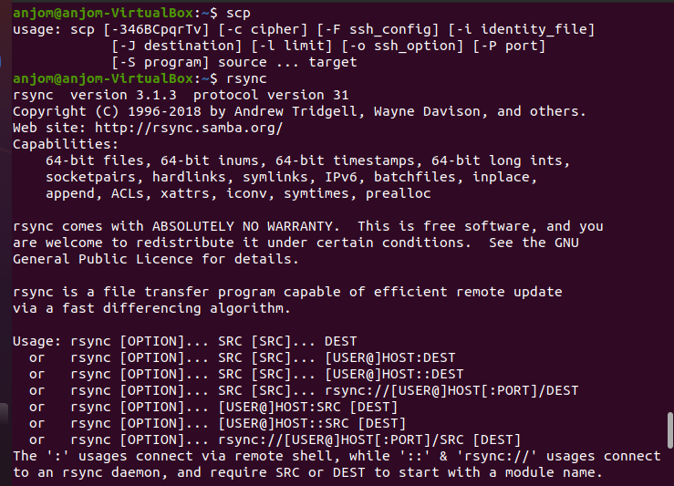

# RSYNC: It’s commonly found on UNIX-Like operating systems. Rsync is written in c as a single threaded application . The rsync algorithm is a type of delta delta encoding and is used for minimizing network usage . Zlib may be used for additional data compression and SSH or stunnel can be used for security.



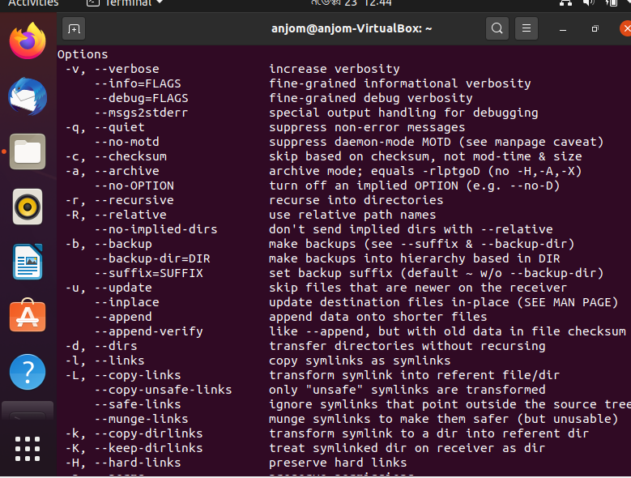

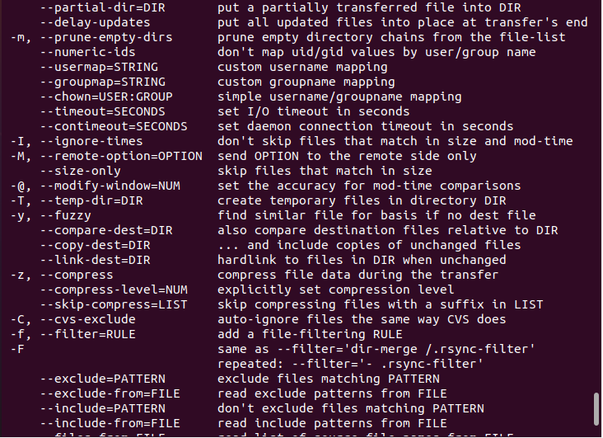

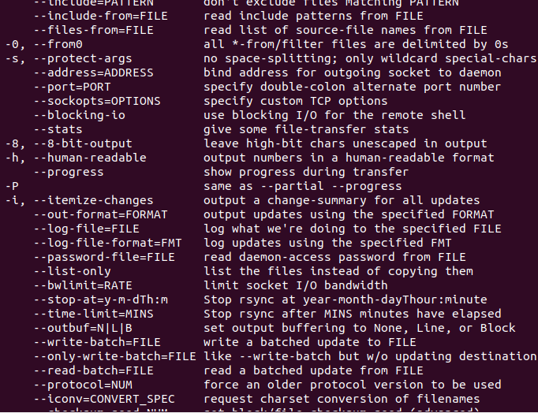

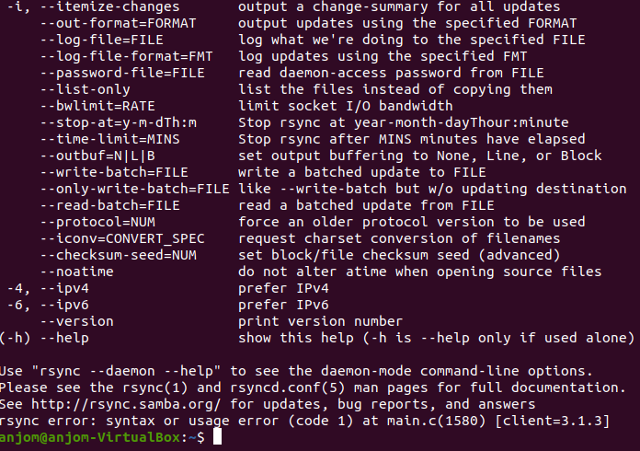

# NGREP: ngrep is a network packet analyzer written by Jorden Ritter. It has a command line interface and relies upon the pcap library and the GNU regex library.

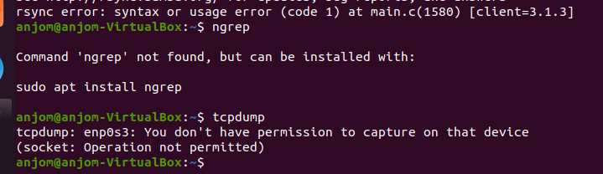

# TCPDUMP: tcpdump is a data network packet analyzer computer program that runs under a command line interface . It allows the user to display TCP/IP and other packets being transmitted or received over a network to which the computer is attached. Distributed under the BSD license , tcpdump is free software.

# Wireshark: Wireshark is the world's leading network traffic analyzer, and an essential tool for any security professional or systems administrator. ... It lets you put your network traffic under a microscope, and provides tools to filter and drill down into that traffic, zooming in on the root cause of the problem

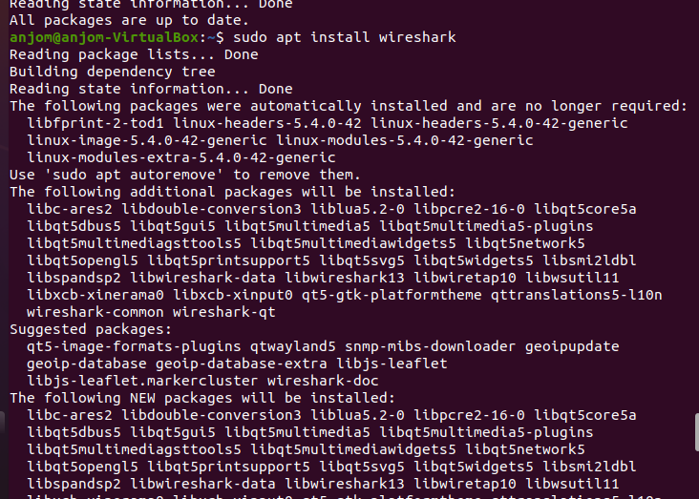

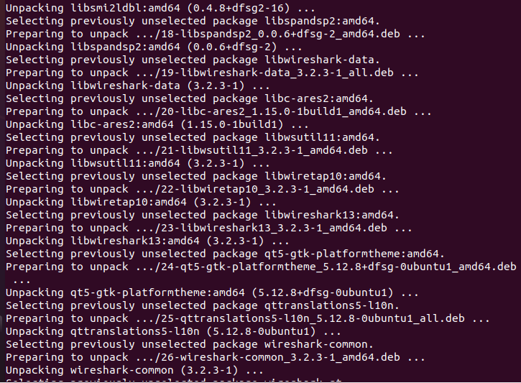

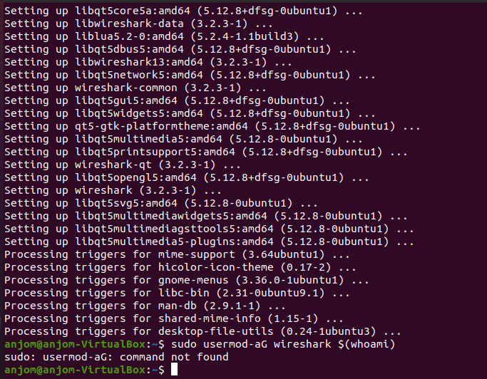

# Wireshark: weireshark is a packet sniffer and analysis tool. It captures network traffic on the local network and stores that data for offline analysis. Wireshark captures network traffic from Ethernet, Bluetooth , Wireless , Token Ring, Frame Relay connections and more.



# Ifconfig: ifconfig is a system administration utility in Unix-like operating systems for network interface configuration. The utility is a command-line interface tool and is also used in the system startup scripts of many operating systems.

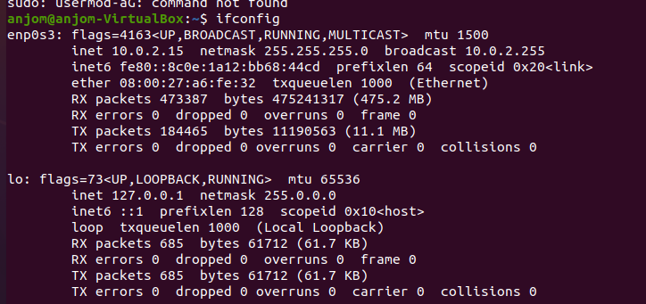

# Route: Routing is the process of selecting a path for traffic in a [network](https://en.wikipedia.org/wiki/Network_theory) or between or across multiple networks. Broadly, routing is performed in many types of networks, including [circuit-switched networks](https://en.wikipedia.org/wiki/Circuit_switching), such as the [public switched telephone network](https://en.wikipedia.org/wiki/Public_switched_telephone_network) (PSTN), and [computer networks](https://en.wikipedia.org/wiki/Computer_network), such as the [Internet](https://en.wikipedia.org/wiki/Internet).

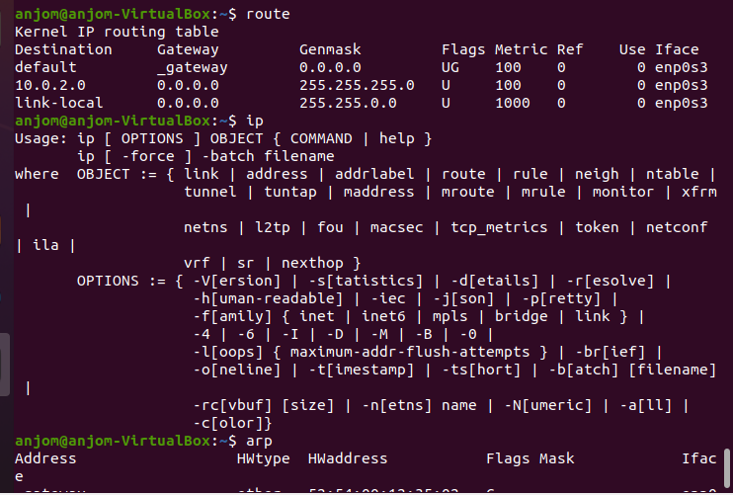

# Ip: An Internet Protocol address (IP address) is a number assigned to any machine that has a computer network and that uses the internet protocol for communicating. Neustar IP Tools provide calculators and real-time lookups to assist you with your day-to-day system administration and research tasks.



# Arp: The arp (address resolution protocol) is a simple Windows network command-line utility used to view and manage the arp cache. The arp cache is a collection of IP and MAC addresses of devices on your local network that your computer knows about. This tool is typically used in troubleshooting network issues.

# Mitmproxy: Mitmproxy is a free, open-source tool whose killer feature is the ability to inspect Transport Layer Security (TLS)-encrypted mobile phone app traffic. The tool is superior to Wireshark when it comes to examining TLS-encrypted network traffic, and its zero-dollar price point beats out the not-cheap Burp Suite.

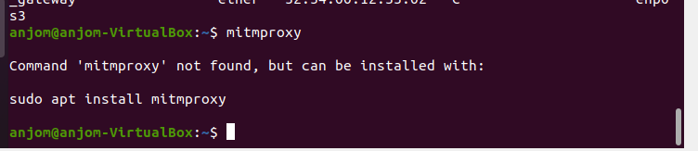

# Iw: Wireless tools for Linux is a collection of user-space utilities written for [Linux kernel](https://en.wikipedia.org/wiki/Linux_kernel)-based operating systems to support and facilitate the configuration of device drivers of [wireless network interface controllers](https://en.wikipedia.org/wiki/Wireless_network_interface_controller) and some related aspects of networking using the Linux Wireless Extension. The Wireless tools for Linux and Linux Wireless Extension are maintained by Jean Tourrilhes[[1]](https://en.wikipedia.org/wiki/Wireless_tools_for_Linux" \l "cite_note-1) and sponsored by [Hewlett-Packard](https://en.wikipedia.org/wiki/Hewlett-Packard).

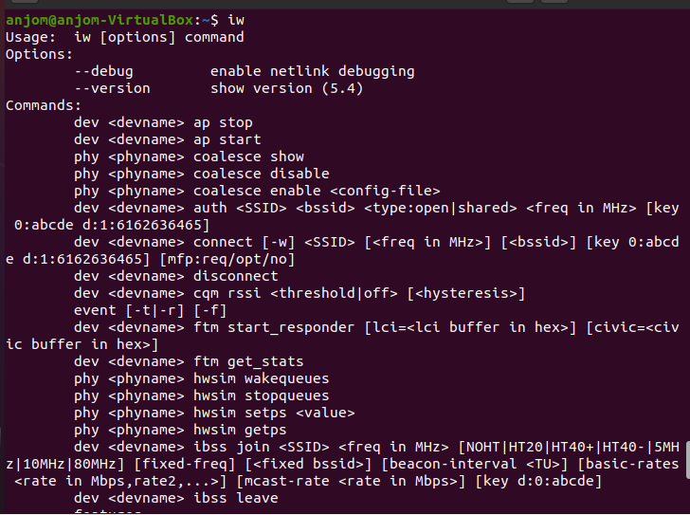

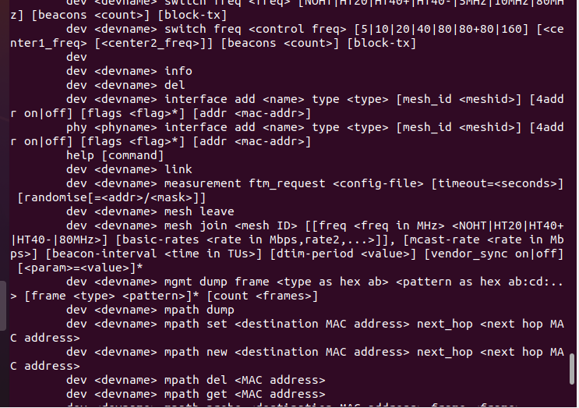

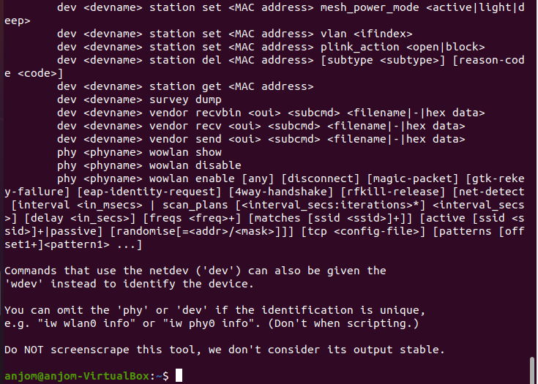

# Sysctl: sysctl is a software utility of some [Unix-like](https://en.wikipedia.org/wiki/Unix-like) operating systems that reads and modifies the attributes of the system [kernel](https://en.wikipedia.org/wiki/Kernel_(operating_system)) such as its version number, maximum limits, and security settings.[[1]](https://en.wikipedia.org/wiki/Sysctl#cite_note-n-sysctl-7-1) It is available both as a [system call](https://en.wikipedia.org/wiki/System_call) for compiled programs, and an administrator command for interactive use and scripting. [Linux](https://en.wikipedia.org/wiki/Linux) additionally exposes sysctl as a [virtual file system](https://en.wikipedia.org/wiki/Virtual_file_system).

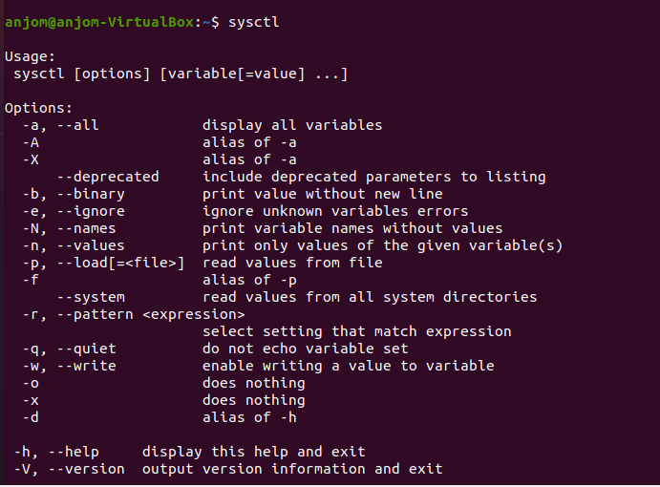

# Nesnter:

# 